**Exercise 2: Implementing the Factory Method Pattern**

**Scenario:**

You are developing a document management system that needs to create different types of documents (e.g., Word, PDF, Excel). Use the Factory Method Pattern to achieve this.

**Steps:**

1. **Create a New Java Project:**
   * Create a new Java project named **FactoryMethodPatternExample**.
2. **Define Document Classes:**
   * Create interfaces or abstract classes for different document types such as **WordDocument**, **PdfDocument**, and **ExcelDocument**.
3. **Create Concrete Document Classes:**
   * Implement concrete classes for each document type that implements or extends the above interfaces or abstract classes.
4. **Implement the Factory Method:**
   * Create an abstract class **DocumentFactory** with a method **createDocument()**.
   * Create concrete factory classes for each document type that extends DocumentFactory and implements the **createDocument()** method.

**PROCEDURE :**

**1.Define Document Classes**

1.Create a New Java Interface:

• In the Explorer view, right-click on the src folder and select New File.

• Name the file Document.java.

2.Implement the Document Interface:

• Open Document.java and add the following code:

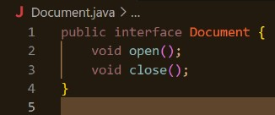

**2. Create Concrete Document Classes**

1. Create Word Document Class:

• Name the file WordDocument.java.

2.Implement the Word Document Class:

• Open WordDocument.java and add the following code:

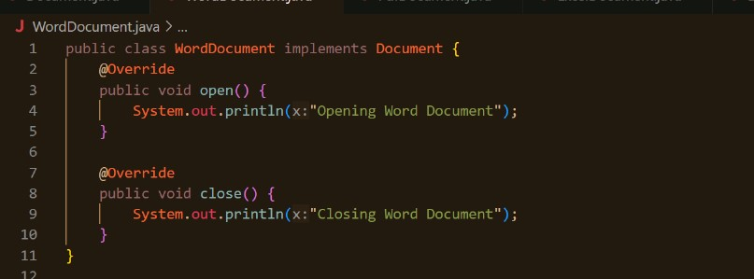

**3. Create PDF Document Class:**

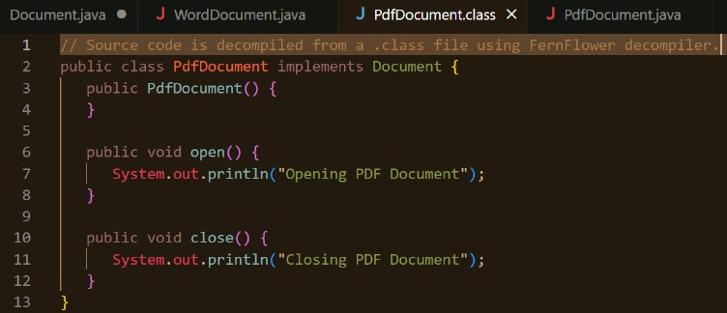

**4.Implement the PDF Document class :**

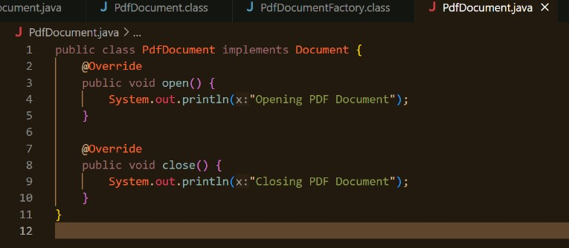

**5.Create Excel Document Class:**

a. Name the file ExcelDocument.java.

b. Implement the Excel Document Class:

c. Open ExcelDocument.java and add the following code:

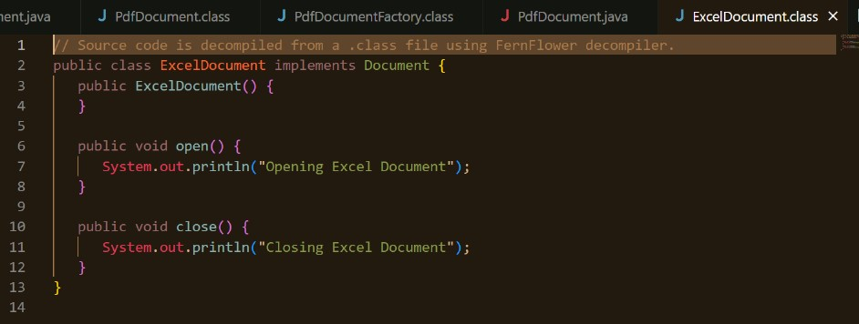

**6.Create an Abstract Document Factory Class:**

a. Create and Name the file DocumentFactory.java.

b. Implement the Document Factory Class:

c. Open DocumentFactory.java and add the following code:

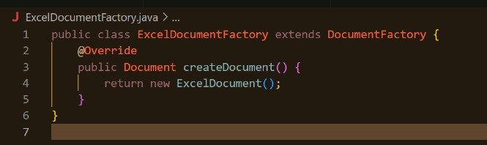

d. Create WordDocumentFactory.java, PdfDocumentFactory.java, ExcelDocumentFactory.java.

**7. Create Test Class :**

a. Create and Name the file as DocumentManagementSystem.java. Now, implement this.

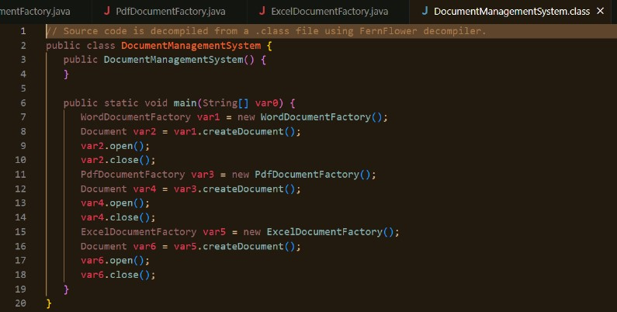

**8. Run the Application and Test Cases :**

a. Compile java files and Execute the DocumentManagementSystem Class.

**OUTPUT :**

